Truncated Triangular Prism

Definition
# Source: AI Source: Provided by: [Data Path: Persons Table -> ID Column: 1, Name_En Column: Motasem Essam] -> From: [ChatGPT] on [7/25/2026]
A Truncated Triangular Prism is a solid formed by cutting a triangular prism with an inclined plane that intersects all three lateral edges, removing the portion above or below the cutting plane.
The resulting solid has:
- One original triangular base.
- One new triangular face created by the inclined cut.
- Three lateral faces connecting the two triangular faces.
This is the classical solid-geometry meaning of a truncated triangular prism.

Geometric Structure
# Source: AI Source: Provided by: [Data Path: Persons Table -> ID Column: 1, Name_En Column: Motasem Essam] -> From: [ChatGPT] on [7/25/2026]
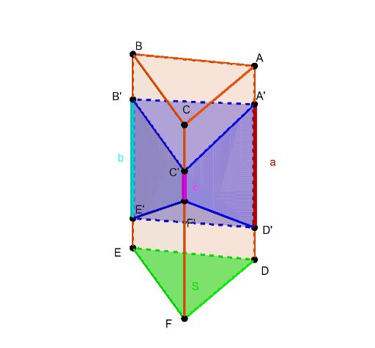
- Original base: The triangular face at the bottom.
- Inclined section: The triangular face produced by the cutting plane.
- Lateral edges: The three edges connecting corresponding vertices of the two triangular sections.
- Lateral faces: Three quadrilateral faces connecting the original base to the inclined section.

Face Composition

Original Triangular Face
# Source: AI Source: Provided by: [Data Path: Persons Table -> ID Column: 1, Name_En Column: Motasem Essam] -> From: [ChatGPT] on [7/25/2026]
The remaining original base of the triangular prism.
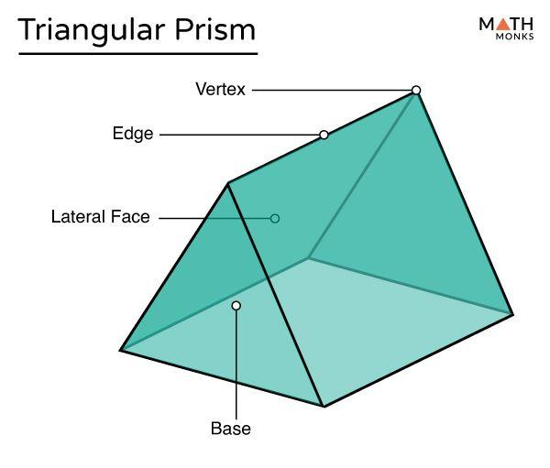

Inclined Triangular Face
# Source: AI Source: Provided by: [Data Path: Persons Table -> ID Column: 1, Name_En Column: Motasem Essam] -> From: [ChatGPT] on [7/25/2026]
The new triangular face formed by the cutting plane.
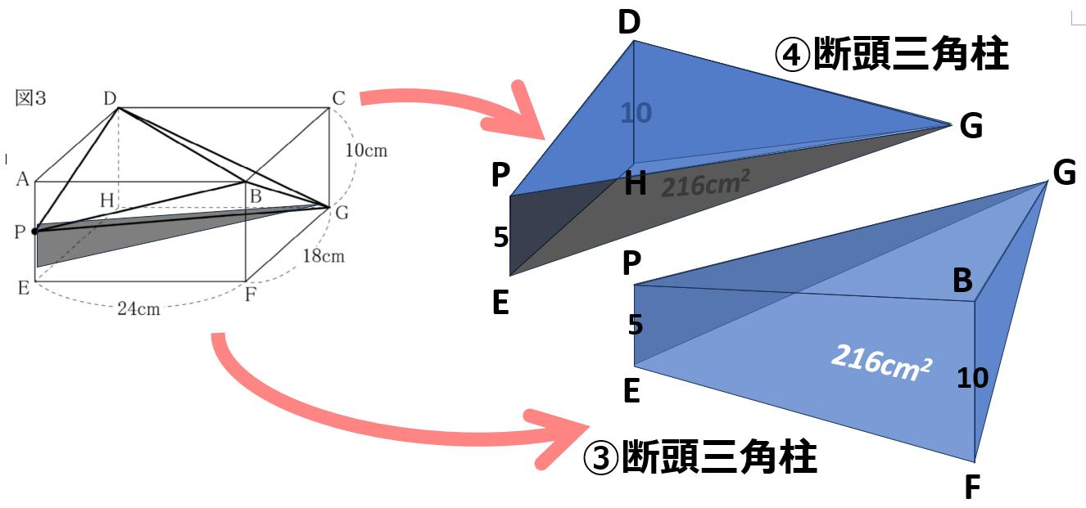

Quadrilateral Lateral Faces
# Source: AI Source: Provided by: [Data Path: Persons Table -> ID Column: 1, Name_En Column: Motasem Essam] -> From: [ChatGPT] on [7/25/2026]
The side faces connecting the original triangular base to the inclined triangular section.
Total face composition: 2 triangular faces + 3 quadrilateral faces = 5 faces.


Mathematical Properties
# Source: AI Source: Provided by: [Data Path: Persons Table -> ID Column: 1, Name_En Column: Motasem Essam] -> From: [ChatGPT] on [7/25/2026]
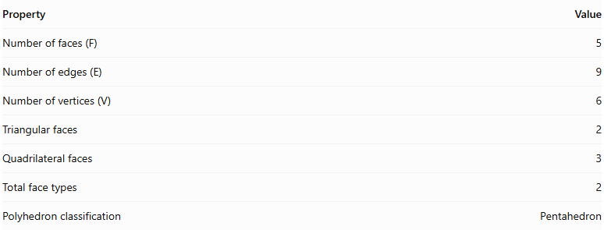
Property | Value
Number of faces (F) | 5
Number of edges (E) | 9
Number of vertices (V) | 6
Triangular faces | 2
Quadrilateral faces | 3
Total face types | 2
Polyhedron classification | Pentahedron
Euler's Formula
$$V-E+F=2$$
$$6-9+5=2$$
Volume Formula
For a right triangular prism cut by an inclined plane, the volume is:
$$V=A(\frac{h_{1}+h_{2}+h_{3}}{3})$$
Where:
- $A$ = area of the triangular base.
- $h_{1},h_{2},h_{3}$ = perpendicular heights measured at the three vertices of the triangular base.

Constructing a Truncated Triangular Prism

Geometric Instruments
# Source: AI Source: Provided by: [Data Path: Persons Table -> ID Column: 1, Name_En Column: Motasem Essam] -> From: [ChatGPT] on [7/25/2026]
The following instruments can be used to construct a truncated triangular prism using traditional geometric drawing methods:
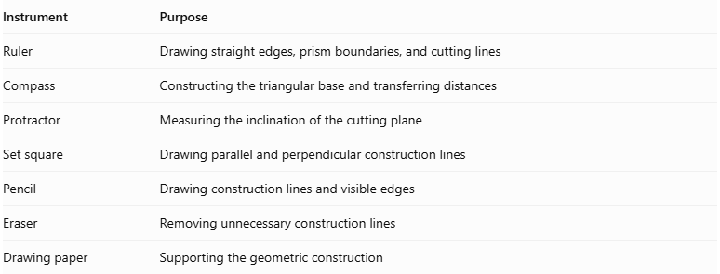
Instrument | Purpose
Ruler | Drawing straight edges, prism boundaries, and cutting lines
Compass | Constructing the triangular base and transferring distances
Protractor | Measuring the inclination of the cutting plane
Set square | Drawing parallel and perpendicular construction lines
Pencil | Drawing construction lines and visible edges
Eraser | Removing unnecessary construction lines
Drawing paper | Supporting the geometric construction
Important geometric distinction: Unlike a prismoid, a truncated triangular prism has an original triangular base and an oblique triangular cutting face that are generally not parallel. The cutting plane intersects all three lateral edges.

Instrument-Based Construction Procedures

Method 1: Constructing by an Oblique Cutting Plane
# Source: AI Source: Provided by: [Data Path: Persons Table -> ID Column: 1, Name_En Column: Motasem Essam] -> From: [ChatGPT] on [7/25/2026]
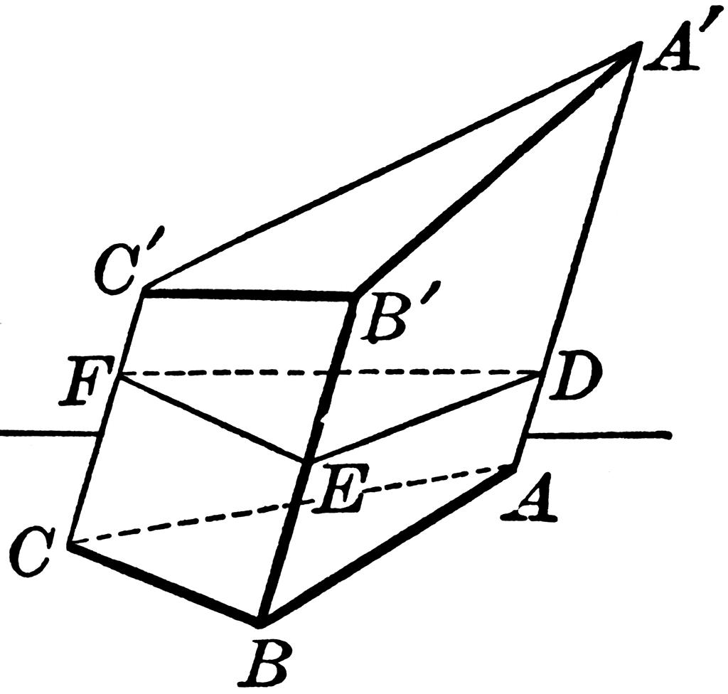
- Draw the original triangular base $ABC$ using a ruler and compass.
- Construct the three lateral edges of the triangular prism, extending from $A$, $B$, and $C$.
- Draw the opposite triangular face of the prism, parallel and congruent to the original base.
- Determine the required inclination and position of the cutting plane using a protractor.
- Mark the three points $A'$, $B'$, and $C'$ where the cutting plane intersects the three lateral edges.
- Connect $A'$, $B'$, and $C'$ to form the oblique triangular cutting face.
- Retain the portion between the original base and the cutting plane.
- Complete the three lateral quadrilateral faces.
- Distinguish visible edges from hidden edges.
- Erase unnecessary construction lines.

Method 2: Constructing from Orthographic Views
# Source: AI Source: Provided by: [Data Path: Persons Table -> ID Column: 1, Name_En Column: Motasem Essam] -> From: [ChatGPT] on [7/25/2026]
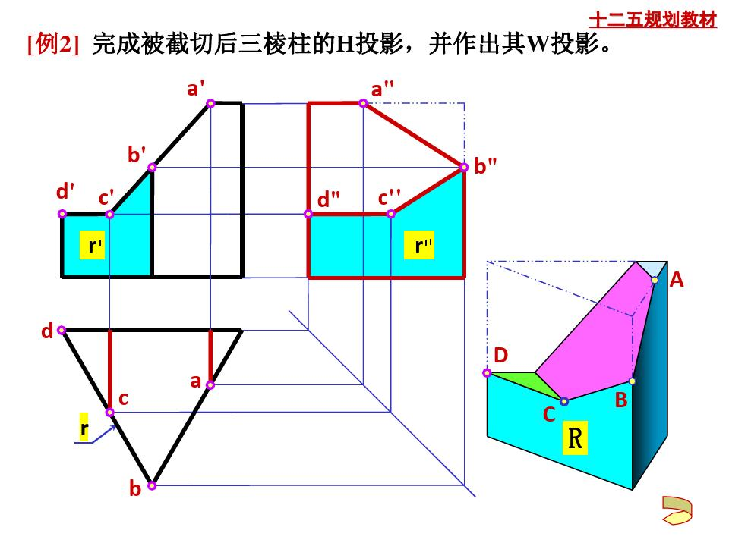
- Draw the triangular base in the top view.
- Construct the front elevation of the triangular prism.
- Draw the three lateral edges at the required prism length.
- Draw the cutting plane in the elevation at the specified inclination.
- Mark the intersection points of the cutting plane with all three lateral edges.
- Project the intersection points into the corresponding positions in the top view.
- Connect the projected points to determine the triangular cutting boundary.
- Complete the orthographic views.
- Construct the isometric representation using the obtained intersection points.
- Mark visible and hidden edges.

Method 3: Constructing Through Three Different Lateral Heights
# Source: AI Source: Provided by: [Data Path: Persons Table -> ID Column: 1, Name_En Column: Motasem Essam] -> From: [ChatGPT] on [7/25/2026]
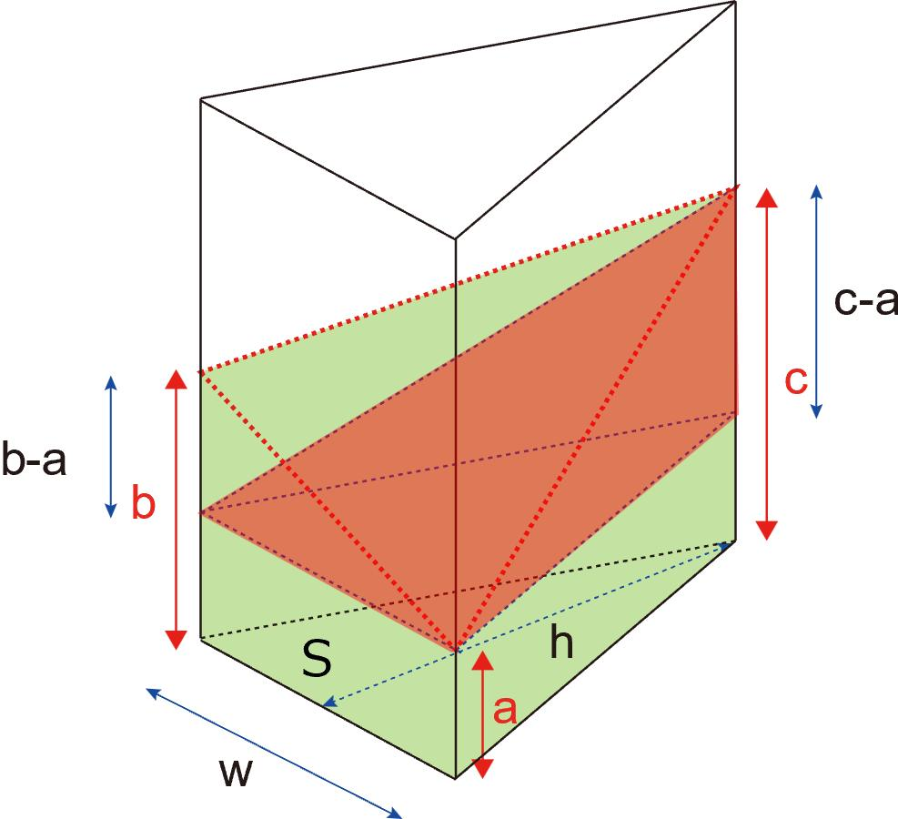
- Draw the original triangular base $ABC$.
- Establish three lateral heights $h_{A}$, $h_{B}$, and $h_{C}$.
- Mark point $A'$ at height $h_{A}$ along the lateral edge from $A$.
- Mark point $B'$ at height $h_{B}$ along the lateral edge from $B$.
- Mark point $C'$ at height $h_{C}$ along the lateral edge from $C$.
- Connect $A'$, $B'$, and $C'$ to form the cutting face.
- Connect the corresponding base vertices to the cutting-face vertices.
- Complete the three lateral quadrilateral faces.
- Verify that the cutting face is planar.
- Finalize the solid by distinguishing visible and hidden edges.

Key Points
# Source: AI Source: Provided by: [Data Path: Persons Table -> ID Column: 1, Name_En Column: Motasem Essam] -> From: [ChatGPT] on [7/25/2026]
- It is formed by cutting a triangular prism with an inclined plane.
- The cutting plane intersects all three lateral edges.
- It has two triangular faces and three quadrilateral lateral faces.
- It contains 5 faces, 9 edges, and 6 vertices.
- Its upper triangular section is generally inclined relative to the original base.
- Its volume depends on the three heights at the vertices of the triangular base.

Conclusion
# Source: AI Source: Provided by: [Data Path: Persons Table -> ID Column: 1, Name_En Column: Motasem Essam] -> From: [ChatGPT] on [7/25/2026]
The Truncated Triangular Prism is a portion of a triangular prism bounded by its original triangular base and an inclined triangular section. It has three quadrilateral lateral faces, giving it a total of 5 faces, 9 edges, and 6 vertices.

